**Hack4Ag Uganda**

**Developing ICT innovations and entrepreneurship in Ugandan agriculture**

**AGRICULTURE EXTENSION SYSTEM FOR UGANDA**

**System Design**

|  |  |
| --- | --- |
| **Revision** | **1.0** |
| **Project Idea** | **Agricultural Extension System For Uganda** |
| **Competition** | **Hack4Ag Uganda** |
| **Organizer** | **World Bank’s Agriculture Global Practice (GFADR), Government of Uganda under the Ministry of Agriculture, Animal Industries, and Fisheries , Government of South Korea, Agriculture Cluster Development Project (ACDP)** |
| **Team Leader** | **Andrew Kigundu** |
| **Author** | **Kayizzi Jonathan Kibaddawo** |
| **Project Delivery Team** | **Andrew Kigundu, Kayizzi Jonathan K, Namwoyo Evelyn,** |
| **Date** | **31st January, 2016** |

Contents

BACKGROUND 2

INTRODUCTION 2

SYSTEM DESIGN 2

USE CASE 2

USE CASE SCENARIO 2

USE CASE DIAGRAM 4

DATA MODEL 5

DATABASE MODEL 5

DATABASE DESIGN 5

# BACKGROUND

# INTRODUCTION

# SYSTEM DESIGN

## USE CASE

### USE CASE SCENARIO

#### Typical Use Case Scenario

The system admin logs in the system admin panel.

The system admin through the system admin panel manages (creates, edits and deletes) location information (districts, counties, sub-counties, parishes and villages).

In the system admin panel, the system admin manages (creates, edits and deletes) agent accounts and assigns locations to agents.

The system admin also manages (creates, edits and deletes) agricultural regional experts’ accounts information via the system admin panel.

The agents use the agents accounts’ information to get authenticated into the system and once authenticated, they can collect and manage (create, edit and delete) market information (market information and market prices), collect and manage (create, edit and delete) household information (House hold details, Household Crop Information, Household Livestock Information, Livestock products information and Household farming tools) and collect and manage (create, edit and delete) abnormalities information (for both crops and livestock) .

Agricultural Regional Experts use the agricultural regional experts’ accounts information to get authenticated into the system and once authenticated, they view the abnormalities information submitted by agents, identify the abnormalities and provide advice for resolving them.

The system is to make use of the Open Weather Map Web System through its APIs to update weather forecast information.

### USE CASE DIAGRAM

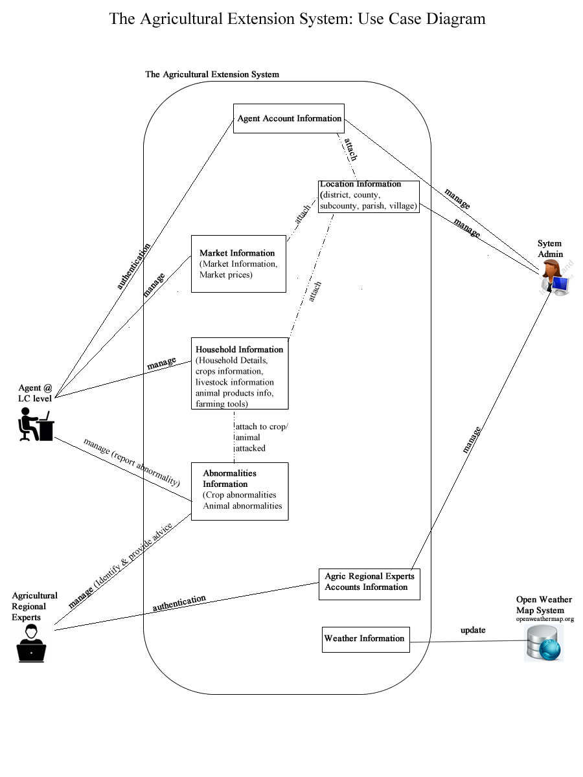

## DATA MODEL

### DATABASE MODEL

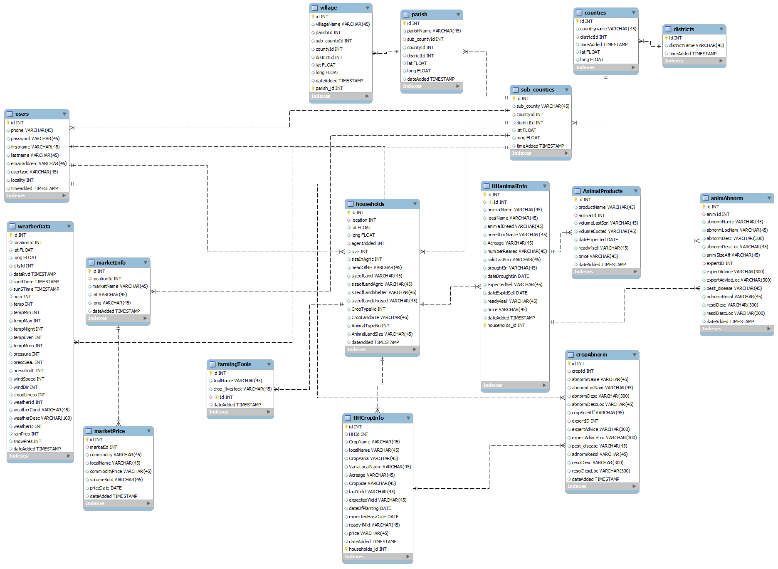

### DATABASE DESIGN

